Carbon Management Plan Review Highlights
Background
The Royal Central School for Speech and Drama (‘Central’) Carbon Management Plan published in 2011 identified a number of projects to reduce carbon emissions by 25% by August 2015 from a 2009/10 baseline.

Central’s Carbon Management Plan set a target to reduce its carbon emissions from energy consumption by 25% in absolute terms from the 2009/10 baseline by August 2015. It also included an aspirational target of achieving a 40% reduction from 2005/06 by 2020 following a higher education sector target of 34% reduction from 2005/06 by 2020 (Table 1).

Table 1: Central's carbon emissions reduction targets

2005/06 | 2009/10 | 2015 | 2020
 | 25% reduction on 2005/06 | 25% reduction on 2009/10 baseline | 40% reduction on 2005/06 baseline
653tCO2 BASELINE | 689tCO2 from electricity, gas, water  BASELINE | 516tCO2 Target | 392tCO2 Target

Performance against CMP 2011
- The 2009/10 baseline for Central’s previous carbon management plan included gas, electricity and water consumption emissions was calculated as 697.57tCO2e.
- Over the last ten years Central have reduced carbon emissions by 25.52%

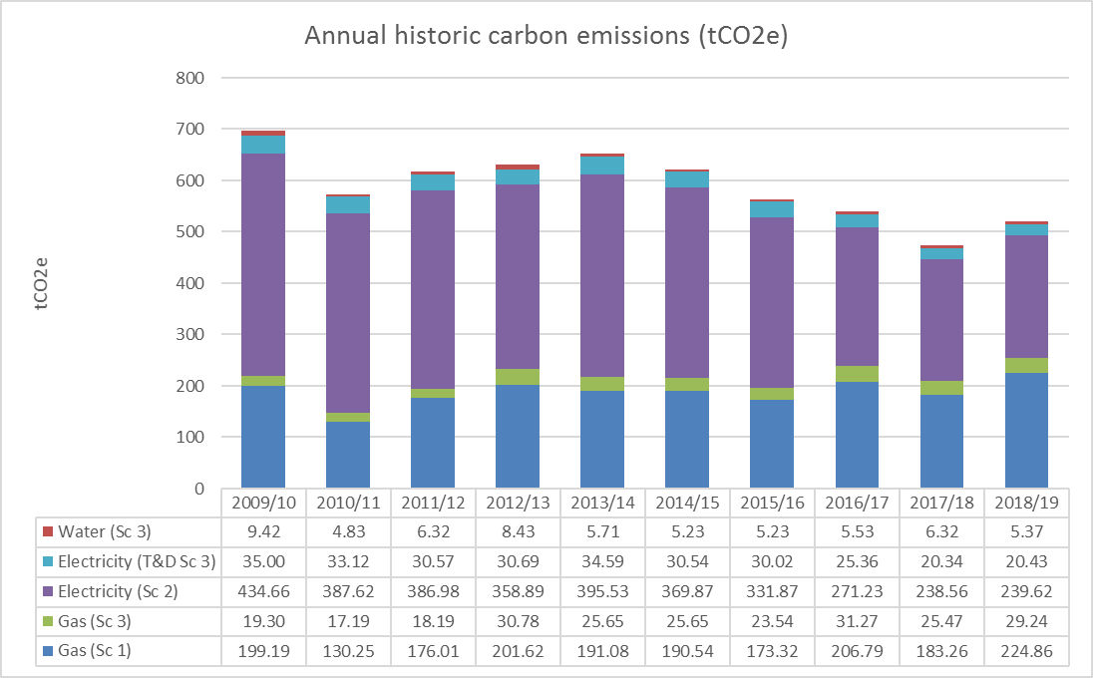

This was achieved by undertaking a number of projects:

Energy and Utility Efficiency Projects
The facilities management team has implemented an extensive programme of small-medium electricity, gas and water efficiency projects relating to lighting, small appliance use, building management system (BMS) controls and local boiler efficiency. The projects focussed on short- medium payback projects across the sites:

- Optimiser and resetting of boiler controls
The Main Building and Theatre Extension optimisers were replaced in 2018 with the Trend Building Management System (BMS) allowing more control by the estates manager.

- Boiler replacement and insulation
Main Building and Theatre Extension boilers have been replaced. Boilers were replaced in 2018 and boiler rooms in Main Building and Embassy Extension have been lagged.

- Installation of variable speed drives
Main pumps have been replaced in the Main Building and Theatre Extension.

- Removal of ancillary devices
Toasters and kettles are now only used in the staff room.

- Lighting upgrade and controls
Lighting in the main building foyer area has been upgraded to LED. Studio lights in the West Block have been replaced with low wattage LED fittings. All down lighting in the East Block have been replaced with low wattage LED fittings. Lamps in the Theatre Extension communication areas have been replaced.

BREEAM Excellent Build of North Block
The new North Block building to BREEAM Excellent standard was opened in 2019. The block offers a studio, 5 high ceiling rehearsal spaces and a new public theatre with LED lighting and PIR lighting controlled in all possible areas.

Solar Photovoltaic (PV) Installation
Solar photovoltaics were installed on the Old Building in 2019.

Carbon and Sustainability Awareness
Awareness and behaviour change campaigns for staff and students have taken place over time covering a range of areas including energy such as through switch off campaigns.

Next steps
The Carbon Management Review identified a number of other areas to consider in the carbon footprint going forward in addition to the energy and water consumption that had previously been considered. The additional areas to be included in the update Carbon Management Plan include waste, travel and commuting.

