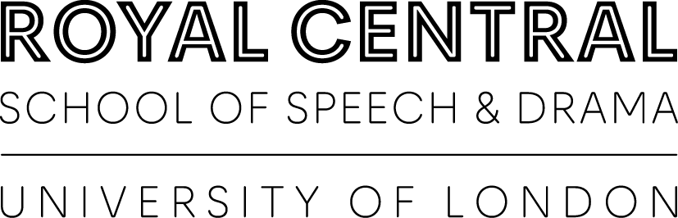

BUFFERING 2021 Program
(Accessible Version)

Welcome.

We are BUFFERING.

Royal Central School of Speech and Drama BA (Hons) Contemporary Performance Practices - Drama, Applied Theatre and Education - are pleased to present our digital student-led projects in two nights of online showcases.
Within two showcases, there will be an array of different digital theatre and performance practice, exploring innovative ways of creating anew and adapting our drama, applied theatre and education practice.
Being in lockdown has forced us to think of and utilise new and innovative ways in which we can create, harnessing the potential of the digital space to push boundaries.
We can’t wait to share it with you...
Follow us:
https://www.instagram.com/bufferingart/
https://twitter.com/buffering20211?s=21

Event Details

Event Page: https://www.cssd.ac.uk/events/buffering-2021

BUFFERING will take place over two nights in order to show the whole group's work. The first showcase hosts a range of digital work via ZOOM webinar. The second, hosting more film- orientated work, will take place via Youtube live stream.
Click or scan the QR codes above to collect your free tickets: here you will receive a link to your chosen showcase's online location.
Please note: showcase 2 is strictly an 18+ event, frequently dealing with explicit content or themes which may be upsetting for some viewers. You are welcome to retire at any point.

Showcase 1: https://www.eventbrite.co.uk/e/buffering-digital-slp-showcase-1-tickets-153444393311

Showcase 2: https://www.eventbrite.co.uk/e/buffering-digital-slp-showcase-2-tickets-153445390293?aff=ebdsoporgprofile

Created over two terms, the unit has been led by PhD and digital practitioner Anna Woolf, supported by Chuck Lowry, with workshops from Jemma Desai, Steven Tart, Punchdrunk, Access All Areas and Dr Nicky Abraham to name a few!

Contact Information.
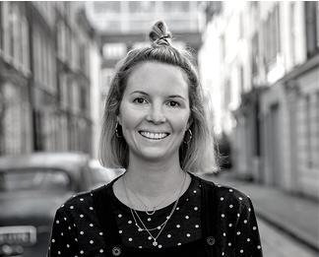
Anna Woolf:
https://www.annawoolf.net
https://www.instagram.com/socialmediamum/
https://www.linkedin.com/in/annabosworth/

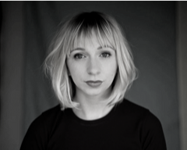
Chuck Lowry:
https://www.chuckbluelowry.com
https://www.instagram.com/chuckbluelowry/
https://twitter.com/ChuckBlueLowry

Jemma Desai:
https://www.instagram.com/iamjemmadesai/

Steven Tart:
https://www.linkedin.com/in/steven-tart/

Punchdrunk:
https://www.punchdrunk.org.uk

Access All Areas:
http://www.accessallareastheatre.org

Dr Nicky Abraham:
https://www.cssd.ac.uk/staff-profiles/dr-nicola-abraham

Schedule
Times are approximate.

Showcase 1 (26.05.2021)

18:30 WELCOME TO BUFFERING by Anna Woolf.

18:40 THE OBJECT ARCHIVE by Lewis, Emma, Phoebe.

18:55 TALENTS OF MAPLEFIELDS by Amber Mcfarquhar.

19:10 OUR RED TENT by Naomi, Safura, Sophie.

19:25 QUEER CODING by Rebecca Prentice.

BREAK

19:50 LUCIDUS by Louise & Angelina.

20:05 YOU’LL GROW HAIR ON YOUR HANDS! by Rebeckah Turbett.

20:20 FINDING LUCIE by Melissa, Moe & Saffron.

20:30 EVENT CLOSING by Anna Woolf.

Showcase 2 (27.05.2021)

18:30 LOOKING ON THE BRIGHT SIDE by Neva Ventullo.

18:40 UNEXPECTED ITEMS by Hannah Margerison.

18:50 ME & MY BAG by Ghazi Al-Ruffai.

19:00 SEVERANCE by Luke Aaron.

19:10 UNHEARD_VOICES.MOV by Chloe Owen.

19:20 SLEEP! By Justin Cromme.

19:30 IT’S NOT HOME by Alexandra Netea.

19:40 US TO YOU by Isabelle Kirkham.

19:50 BURN THE STREGA by Chiara Virgilio.

20:00 THE BABY by Jakub Repisky.
20:10 NOT MY TEMPLE, MY HOME by Celeste Da-Palma.

20:20 IT’S CALLING ME by Noah Heathcote.

Showcase 1 (26.05.2021)
Eventbrite: https://www.eventbrite.co.uk/e/buffering-digital-slp-showcase-1-tickets-153444393311

The Object Archive
By Lewis, Emma, Phoebe.

“Home is where the archive is…”

Content Warning: Explicit Language and Bereavement Themes.

Project Link: https://www.notion.so/The-Object-Archive-a4aaeda3ff834697966986d49f4c55da

Details
The Object Archive is an interactive space designed to investigate the meaning behind personal objects and the stories generated from the relationship with their owners, providing a platform to create community, digitally.
This is a group project by Lewis Milligan, Emma Ibbot and Phoebe Whiley.

Profile
Lewis is an emerging theatre-maker and teacher, interested in theatre in education settings, promoting space for community and wellbeing. Experienced in immersive theatre and participatory practice, he's interested in applying the potentials of theatre to positively modify the mechanics of the education system.
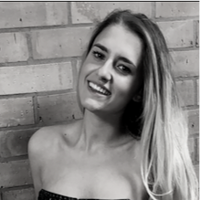
Emma's an experienced theatre practitioner- facilitator who uses theatre in educational settings. She aspires to be a primary school teacher after completing her PGCE - deploying her creative theatre experience and knowledge to enhance children's learning further.
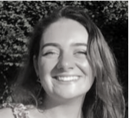
Phoebe's (she/her) passionate about education of young people, particularly interested in how theatre and arts in Relationship & Sex Ed (RSE). She believes creativity is the best way these lessons and discussions can be facilitated.

Contact Details
Emma.ibbot@cssd.ac.uk
Lewis.milligan@cssd.ac.uk
Phoebe.whiley@cssd.ac.uk

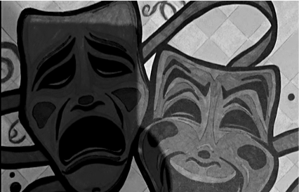
Talents of Maplefields
By Amber McFarquhar.

“We are much more than your next statistic.”

Details
A digital performance demonstrating the talents from secondary school students at Maplefields Academy. This piece has been created by the students, from filming, editing and the ideas they wished to present. It details previous students journey among with current students.
“Caution: contains intense talent!”

Profile
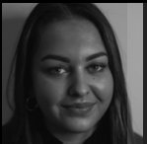
Amber is an Applied Theatre student and has a keen interest in how Applied Theatre and Drama can be utilised within education. In particular, how it can help students in a specialist educational needs provision. She has undertaken academic research in Special Educational Needs (SEN) schools and also educational theatre. She has now secured a position working full-time as a specialist teaching assistant in a local SEN school; she hopes to further her education by undertaking a masters in Drama Therapy and pursue this area of interest further.

Contact Details
Email: amber.mcfarquhar@cssd.ac.uk
Twitter: https://twitter.com/amber_theatre
Instagram: https://www.instagram.com/farquhar27/
Our Red Tent
By Naomi, Safura, Sophie.

“Close your eyes and think of your favourite space…”

Project Link: https://theredtent21.wixsite.com/my-site

Details
‘Our Red Tent’ is a contemporary exploration of the historical concept of sacred female spaces. Our website serves as a place for young girls to explore their relationship to space and how they can create and reclaim it. It features a gallery of digital sound pieces based on interviews and workshops run with several different women.
This is a group project by Naomi Rosser, Sophia Chambers and Sadura Shaharuddin.

Profile
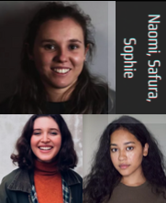
Safura, Sophie and Naomi are a group of female identifying Applied Theatre students who feel that the topic of female friendships in adolescence is often overlooked. They are all interested in digital practice, such as audio performance, which influenced the final piece.

Contact Details
Naomi.rosser@cssd.ac.uk
Sophia.chambers@cssd.ac.uk
Safura.shaharuddin@cssd.ac.uk
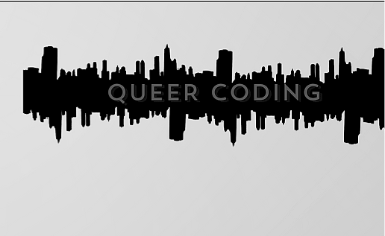
Queer Coding
By Rebecca Prentice.

“The City Belongs to Us.”

Project Link: https://bexprentice.wixsite.com/queercoding

Details
Queerness is embedded in our cities, our parks, our homes, but so often young female and non-binary queers feel disconnected from the world around them. Through modern technology, young queers/LGBTQIA+ are finding community more and more in the digital world; this project will combine the physical and digital to create a dialogue across the community. A living archive of digital artefacts that are embedded in QR codes - or QueeR Codes - all over London. A heaving organism of queer/LGBTQIA+ history, art and presence that you discover on your daily life. This is an insistence to be held and recognised, a growing network of infinite queerness.

Profile
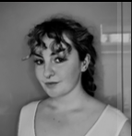
Becca Prentice is a queer woman and theatre practitioner, interested in holding space for community building and conscious resistance to the simplification of identity. Her wider experience is in working with those with experience of forced migration and as such, much of her practice focuses on the reclamation of space and identity through creative and artistic development.

Contact Details
Rebecca.prentice@cssd.ac.uk
Twitter: https://twitter.com/_beccaprentice
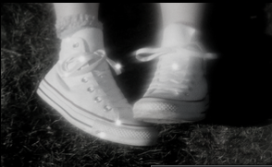
Lucidus
By Louise & Angelina.

“How plane is your reality?”

Content Warning: blood, violence, bugs, explicit language, flashing images, psychological threat, verbal abuse.

Project Link: http://angelinaprom.wixsite.com/lucidusfilm

Details
Lucidus is a multi-video, multi-reality experience through the eyes of Alice, who wishes to escape her current plane of existence and break free from quarantine. Lucidus follows Alice trying to navigate different planes of reality, dreams and nightmares, while exploring themes of agency, fantasy, and dystopia.
This is a group project by Louise Hodson and Angelina Prom.

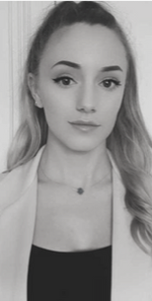
Profile
Louise is a theatre facilitator with an interest I immersive and inclusive performing arts. Louise has worked in early years and in disability arts and loves exploring how playfulness and experimentation can create exciting collaborative work. She enjoys performing and facilitation others and likes to draw on alternative and hyperreal stimuli to push imaginative work.
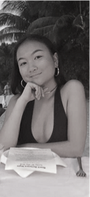
Angelina (She/Her) is an American/Cambodian multi-artist specializing in filmmaking, songwriting and theatre. Previous works of art include Autophobia (2017, winning 2nd place in a film festival), Painting Nostalgia (2018) and Growing Pains (2019).

Contact Details
Louise.hodson@cssd.ac.uk
Angelina.kain@gmail.com
Instagram: https://www.instagram.com/angelinaprom/

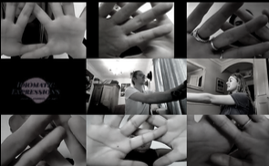
You’ll Grow Hair On Your Hands!
By Rebeckah Turbett

“Can we make love without touch?”

Content Warning: Sexual themes, implied graphic content.

Details
You'll Grow Hair On Your Hands! is a piece of empathy with the young people experiencing coming of age in a covid world.

Profile
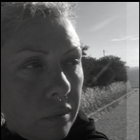
Pronouns: They/Them. An unlabelled itinerant who tries to challenge social norms by holding space. They believe we must always examine what we believe to be broken in order to understand how social norms sub/consciously fix our views of how things "should" be.

Contact Details
Email: rebeckah.turbett@cssd.ac.uk
Instagram: https://www.instagram.com/vsmyth_x_idiomaticexpressions/
Twitter: https://twitter.com/rebeckaht

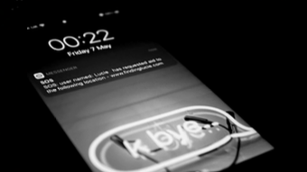
Finding Lucie
By Melissa, Moe, Saffron

“You receive an SOS message from your friend… Can you help find her?”

Content Warning: Consent themes, violence, explicit language.

Project Link: https://findinglucie.wixsite.com/start

Details
Finding Lucie is an online, multi-choice audio experience based around the decisions and stories of a 2:30 hour d&d campaign exploring consent.
This is a group project by Melissa Nelson, Saffron Richardson and Moe Beth.
“Headphones recommended.”

Profile
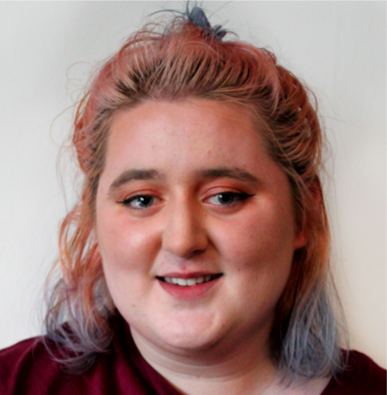
Millie is interested in creating immersive experiences and exploring the links between gaming and performance, specifically the ways in which table-top role playing games can stimulate communal storytelling and ways of devising performance.
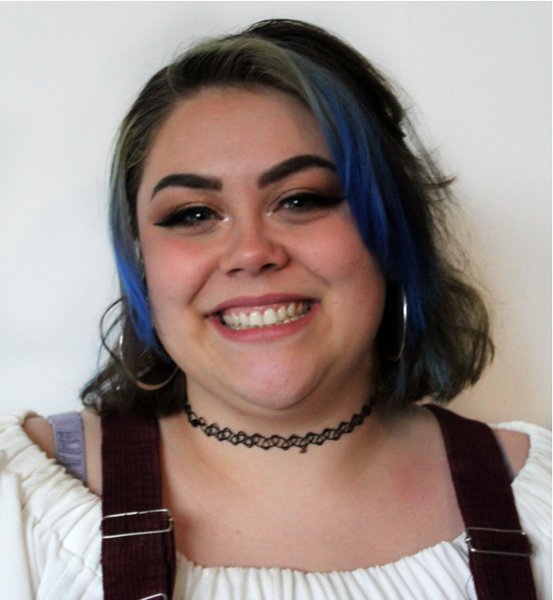
Saffron has an enthusiasm for immersive experiences. She has a particular interest in game-based theatre and how we can use the theatrical space to explore discourses of tension in a controlled cathartic manner. Her focus is around class identity and drama therapy.

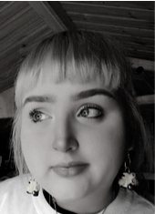
Moe (she/they) is an experienced in performing and facilitating. Their focus is around mental health and using drama to approach it in a new and explorative fashion, they are interested in utilising this with SEN children and young people with mental health problems.

Contact Details
Saffron.richardso@cssd.ac.uk
Mellissa.nelson@cssd.ac.uk
Mollie.hancock@cssd.ac.uk

Showcase 2 (27.05.2021)
Eventbrite: https://www.eventbrite.co.uk/e/buffering-digital-slp-showcase-2-tickets-153445390293

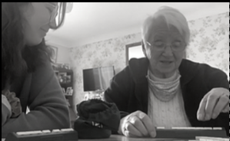
Looking on the Bright Side
By Neva Ventullo

“Looking on the bright side in this moment of history…”

Content Warning: Covid-19 themes

Details
Looking on the Bright Side is a short documentary exploring the relationship between family, a year after Covid-19 pandemic began in the United Kingdom. Recorded entirely on iPhone, this simple film of ‘found footage’ reflects on the power of positivity while living through historical events.
“Headphones recommended.”

Profile
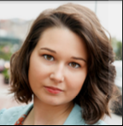
Neva is an emerging theatre artist, performer, and stage manager with a passion for working accessibly and diversely. As a deviser and applied theatre maker, Neva strives to explore new ways of storytelling that challenge the confinements of mainstream theatre. Throughout her student career at both Boston Conservatory at Berklee and Royal Central School of Speech and Drama, Neva has enjoyed the opportunities she had working with and teaching a variety of creatives and looks forward to what the future has in store.

Contact Details
Email: n.ventullo26@gmail.com
Instagram: https://www.instagram.com/neva_luna_26/
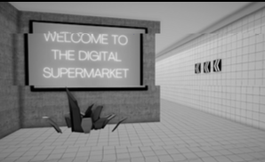
UNEXPECTED ITEMS
By Hannah Margerison

“Unexpected Item in the bagging area…”

Content Warning: Covid-19, anxiety, depression themes.

Details
UNEXPECTED ITEMS is an experience-based digital performance designed for the pandemic age. The performance is durational, multimedia and takes place both on your phone and in the supermarket. This is a work-in-progress, alongside a body of work and research on co-presence in digital performance.

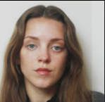
Profile
Hannah (she/her) is an emerging creative producer and performer from North Yorkshire. She is interested in exploring how digital practice interacts with our experience of space and place. She is co-founder of Bellyfeel Theatre Company and is an ambassador for the National Youth Theatre. Previous works include Sheltered (Paradise Venues, Edinburgh Fringe), Pericles (R&D, National Theatre) and The Red Shoes (Pleasance Courtyard, Edinburgh Fringe).

Contact Details
Email: Hannah.margerison@cssd.ac.uk
National Youth Theatre: https://www.nyt.org.uk
Bellyfeel Theatre: https://www.facebook.com/bellyfeeltheatrecompany
Instagram: https://www.instagram.com/hannahmargee/
Twitter: https://twitter.com/hjmarge

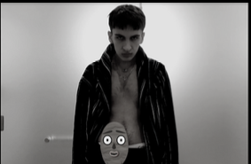
Me and My Bag
By Ghazi Al-Ruffai

“What’s worse than a bag of shit? A talking bag of shit.”

Content Warning: Flashing Images, alcohol themes.

Details
Me and My Bag is a short film exploring Ghazi's personal struggles with Crohn's disease and having an ileostomy bag, using comedy in performance as a tool for information and expression.

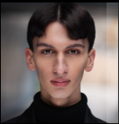
Profile
Ghazi Al Ruffai is a Scottish-Bahraini actor and theatre-maker passionate about using performance to mediate as a social and cultural apparatus for neglected, underrepresented issues of today's world, such as The Man Box, solo- performance dissecting gender expectation in the Arab world. Ghazi has also worked extensively as a lead performer for the Bahraini Ministry of Culture, headlining national festivals of Spring Of Culture and Bahrain Summer Festival. Alongside this, Ghazi is a professional model signed to Contact Agency, and is a part- time artist, specialised in portraiture.

Contact Details
Email: ghazialruffai@hotmail.co.uk
Contact Agency: https://contact.xyz/models/ghazi-alruffai
Instagram: https://www.instagram.com/ghazialruffai/

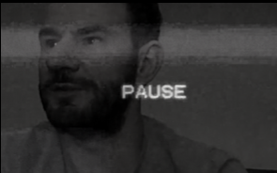
SEVERANCE
By Luke Aaron

“A conversation with Paps…”

Content Warning: Political Themes, Flashing Imagery.

Details
SEVERANCE is a playful and probably unpalatable experimental short-documentary; a creative response to research exploring working-class alienation. Made on a small laptop under lock-down constraints - using Zoom, a potato for a camera, and a drone from a mate - it makes a desperate enquiry into to the real and continuous withdrawal of Labour from the working-class communities it was built to represent. To do so, it must fight to navigate the airwaves to broadcast the unpalatable and dismissed; elucidating the consequences of inaction, political snobbery and working- class demonisation adopted by some of party's newer demographic: contemporary, white, metropolitan, middle-class liberals. Talkin'bout politics is uncomfortable, but if we on the left want things to change politically - if Labour wants it's downfall rectified - then this story is one we have no choice but to start trying to understand.
“Headphones recommended.”

Profile
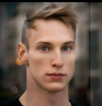
Luke is a working class theatre practitioner- facilitator from the Forest of Dean, with a passion for film - and puppets. Focusing on social class and 'underclass', he's recently been working on a body of work and research exploring the rise of the far-right in working- class communities, like his. While interrogating class injustice, inequality and prejudice in politics, theatre and arts, Luke's been collaborating with Journey to Justice's national Economic Injustice Project, providing insight on intersections of class, arts and the rural.

Contact Details
Email: luke.aaron@cssd.ac.uk
National Youth Theatre: https://www.nyt.org.uk

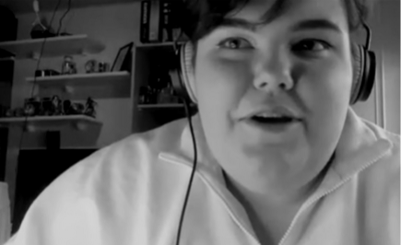
unheard.voices.mov
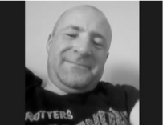
by Chloe Owen
“We are the mechanisms of the machine…”

Project Link: https://chloeowencreative.wixsite.com/chloeowenslp

Details
unheard_voices.mov is a free roaming archival digital space where multiple working class voices are stored. These working class voices are displayed through discussions about working life. These discussions are unedited and you, the audience, can choose whose voice to listen to.

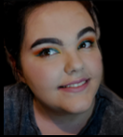
Profile
Hey, I’m Chloe. I feel a bit weird talking about myself in third person, so I am going to be writing this bio like this. I am a working class creative from Gloucester. I am passionate about working class voices being heard in spaces that sometimes can feel unwelcoming. As a working class person, I have felt like that many of times; I have walked into spaces that was clearly built on money and were not made for me. Anyways, I’m getting carried away! Currently working at the Cheltenham Everyman Youth Theatre which is really cool and fun- I don’t want to brag but isn’t that what this blurb thing is? My last short film had been recognised by the BFI Academy which was so amazing! Lastly, I have worked with multiple organisations in my short (but sweet) career so far. To name a few: Strike a Light, Cheltenham Youth Theatre and Gloucestershire College.

Contact Details
Email: chloeowencreative@gmail.com
Twitter: https://twitter.com/Chloe_Creative_
Website: https://chloeowencreative.wixsite.com/
Instagram: https://www.instagram.com/chloeowencreative/

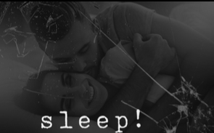
sleep!
By Justin Cromme

“In order to fall asleep, let’s start by closing your eyes…”

Details
A closer look at what sleep does and means in 2021. Examining the commodification of sleep, the intimacies of the bedroom and the negative effect technology has on our sleep patterns, to name a few. Each subject is told in a different format resulting in a lively, spontaneous and refreshing short film on one of the most instinctive activities we do every day: sleep!

Profile
Justin is an international applied theatre student that has gained a passion for using theatre techniques within organizations that focus on personal and group development. Having worked with employee training agencies across the U.K. and in the United States, Justin is working towards setting up his own training agency. Simultaneously, he has gained interest in not only helping others develop their own stories but also telling other peoples stories. This largely focusses on how other individuals experience certain societal discourses. An example of this is his new piece 'sleep!', which takes a closer look at the relationships different people have with sleep.

Contact Details
Email: justin.cromme@cssd.ac.uk

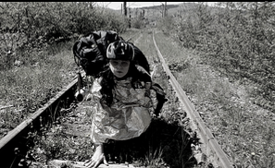
It’s Not Home
By Alexandra Netea

“I’m going to London.”

Content Warning: Explicit Language

Details
The universe of the East-European workers who left their country looking for the Western wellbeing it is picturesque and more complicated that it might seem. Before joining the European Union, the economical migration from the post communism East to the democratic West involved illegal border crossings, undeclared work, camps and forced repatriation, as Western countries' tightened anti-immigration legislation.
Many migrant workers think that abroad you forget about your decency, human dignity being dramatically vulnerable. Others start a new life abroad, being happy and relieved that they were able to “escape” their own country. But both sides feel alienated in one form or another.
“Some fragments may be strong”

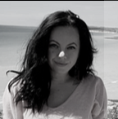
Profile
Alexandra Netea is a Romanian migrant worker in London. She is intersted in becoming a theatre practitioner. After graduating from RCSSD she aims to start a theatre company to work with children, young people and adults from different backrounds.

Contact Details
Email: alexangra.netea@cssd.ac.uk

Us to You
By Isabelle Kirkham

“This is a direct response to all non care experienced people.”

Content Warning: Care Themes, Explicit Language, Flashing Imagery

Project Link: https://reclaimcare.wixsite.com/reclaimcare/allies

Details
Us to You is a piece of spoken word created in collaboration with care experienced people. This is a direct, confrontational response to non-care experienced people and the things they have labelled care experienced people with.

Profile
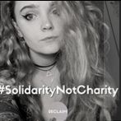
Isabelle is a care experienced theatre maker & vocal advocate. She is always striving to challenge and change all stereotypes about care experienced people in real life & in fiction. She’s currently a founding member of Reclaim Care, A Coram Voice ambassador & aims to use theatre as way to bring about change within the care system & for all care experienced people. After graduating from RCSSD she aims to continue this work with Reclaim Care & Coram Voice alongside her own theatre company “The Unredacted Company”- A theatre company that works with only care experienced people and aims to show a Unredacted view of care.

Contact Details
Email: isabelle.kirkham@cssd.ac.uk
Twitter: https://twitter.com/isabellekirkham/
Reclaim Care: https://reclaimcare.wixsite.com/reclaimcare/allies

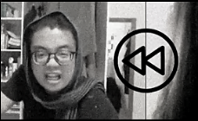
Burn the Strega
“Can the perfect story arise from an imperfect society?”

Project Link: https://matsociety.wixsite.com/matsociety/2020-21-intersectionality

Details
"Burn the Strega - Intersective Narratives" is a digital multilingual performance on the theme of world-wide storytelling which analyses the role of feminine roles in four stories. Starting as a Zoom meeting where the actors tell different tales from various parts of the world, the play evolves into an exploration of the role of "witches" and female antagonists in different cultures. With the aim of acknowledging and challenging the discriminations and perpetration of oppressive systems, the play constantly rewinds to make these narratives more inclusive. But can the perfect story arise from an imperfect society?
“Google translate is prohibited.”

Profile
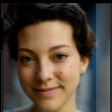
Chiara is a theatre director from Milan (Italy), co- founder and artistic director of the Multicultural Applied Theatre (MAT) Society at the Royal Central School of Speech and Drama. Since 2018, she has directed theatre ad digital performances in 12 languages, exploring through multilingualism themes of migration, displacement and cultural identity. Chiara will graduate from the BA (Hons) Contemporary Performance Practice: Drama, Applied Theatre and Education in July 2021, and continue studying theatre directing on a master's degree.

Contact Details
Email: chiara.virgillo@cssd.ac.uk
Mat Society: https://matsociety.wixsite.com/matsociety
Instagram: https://www.instagram.com/matsociety.iatp/
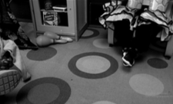
Superstars (The Baby)
By Jakub Repisky.

“Adventure of 8 youngsters willing to work towards their creative outcome!”

Details
Superstars (The Baby) is a short film that maps a journey of 8 superstars walking towards their big adventure. Amaan, Connie, Niam, Muftaah, Jeremiah, Nasrin, Dev and Nicholas have never experienced a role in a movie but they don't hesitate to show all their talent while searching for a missing baby. Will they find it?
“Caution: contains intense talent!”

Profile
Jakub is a lovely-young gentleman who seeks opportunities all around Hanwell. Well... at the moment. He enjoys life as it comes and gradually tries to understand its relative sense. His career is orientated around community's wellbeing on daily bases. But on Sundays, you might find him resting at his house in Hanwell, London. Jakub participates and uses his presence mostly in the SEN sector; he fell in love with this wonderful environment 6 years ago and he seems to be trying to make an impact on young people's happy weeks. Let's see!

Contact Details
Email: Jakub.repisky@cssd.ac.uk

Not My Temple, my home
by Celeste Da-Palma

“I used to have a bad relationship with men and sex, but now I'm in a better place and just really love my vagina!”

Content Warning: Body Image, eating disorder themes, sexual abuse.

Details
Not my Temple, my Home explores what it means to 'feel at home in your body' from a female identifying perspective through the medium of expressive movement, spoken word and verbatim interviews. Different voices of women form a journey of the traumas, joys and experiences of living inside a woman's body and whether feeling at home is a phenomenon that can be reality.
“Headphones recommended.”

Profile
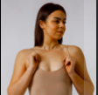
Celeste is a movement performer and director with a specific interest in how the body can be utilised in performance to overcome trauma, express creativity and portray the importance of non-verbal communication through physical gesture and improvisation. Celeste is also a qualified personal trainer and fitness professional, specialising in body composition and body confidence coaching in young females.

Contact Details
Email: celeste.depalma@cssd.ac.uk
Celeste DP Fitness: https://www.celestedpfitness.co.uk
Instagram: https://www.instagram.com/celestedp_fitness/
Email: celeste@celestedpfitness.ac.uk

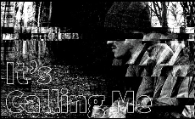
It’s Calling Me
By Noah Heathcote

“In constant flux, we travel beyond, into another world within our own... “

Project Link: https://www.facebook.com/groups/3586726041552943/?ref=share

Content Warning: Loss Themes, Violence, Alcohol abuse.

Details
It's Calling Me is a first short film that looks at a boy in search for something after the loss of his mother. It's a journey of discovery, and re-configuration with the land and himself. He tries to follow the signs around him but it's hard to know what's real as things start to blend with the virtual world.
“Open-mind recommended.”

Profile
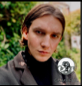
Noah - a human from the planet Earth, maker of things - looks for connections between people and places, virtual and actual, past and present. Using digital technologies as a key part of his practice, he looks at ways for us to deepen our connection with our environment through the use of digital tools. His future narrative looks to create real life games in our actual world, bringing people together in playful environments to disrupt the everyday and find the multiple meanings in spaces. His current passion is in film-making, interactive walks, and an urge to subversively stand up to tyrannical systems through creative form. He also loves watermelons and mindfulness.

Contact Details
Email: noah.heathcote@cssd.ac.uk
Instagram: https://www.instagram.com/gameful_yourworld/
Instagram: https://www.instagram.com/nheathcote/

Credits

BUFFERING would like to thank…

Anna Woolf
Chuck-Blue Lowry
Steven Tart
Bartosz Dylewski
Gemma Desai
Dr Nicky Abraham
Punchdrunk
Access All Areas
Nina Lemon
Ben Buratta
Dr Gareth White
RCSSD Media

