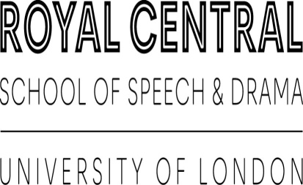
Important notice – Reference
The individual named on the Referee Form (overleaf) has applied for a place on a course at The Royal Central School of Speech and Drama (“Central”). Should they be made an offer, conditions include that they provide a satisfactory academic/professional reference. The individual has named you as a person who would be willing to provide such a reference.
The effect of the form
As outlined above, the main purpose of this exercise is to satisfy offer criteria. If you as the named referee fail to submit a reference, or refuse to supply information, Central will seek further information from the applicant, such as an alternative referee, to confirm their offer.
If the applicant fails to share such information on request, their offer to study at Central may be withdrawn.
Spot checks
We may conduct spot checks on references received as part of our regular reviews of Admissions processes and procedures. Please note, this has nothing to do with the quality of your reference, we are simply seeking to ensure the reliability and validity of our internal procedures in the hope of resolving any issues that may exist – and welcome constructive feedback in this regard.
Named referees who may or may not have shared a reference with us will be selected at random to ensure that the data we hold on our applicants is sufficient, genuine and accurate.
Completing the form
To confirm that the reference provided to Central is authored by you, is factually correct and corresponds with information previously shared with us by the applicant, we would be grateful if you could please sign both this letter (below), and the Referee Form, and return it via a photo/scan or electronic copy to admissions@cssd.ac.uk.
We recommend you retain a copy of the form for your own records.
Please ensure you include the full name of the applicant and the course they have applied to in your email – and ideally their Central ID number (if known).
Acknowledgement by referee
I acknowledge that I have received, read and understood the above notice:
(Referee)

………/………/……… (Date)

REFEREE FORM
Course Title applied to:
Reference date:
Student’s full name:
Student’s address:
Referee’s full name:
Referee’s address:
Referee’s phone:
Occupation:
Employer (if relevant):
Employer address:
Years in employment:
Relationship to the applicant:
Length of time the applicant is known to you:

STATEMENT BY REFEREE
Please write or copy and paste your reference here. Alternatively, please fill out this form, signing and dating where required, and provide a separate reference on headed paper with this form.

DECLARATION BY REFEREE
I confirm that I am:
- not the spouse, co-habitee or close family member of the student;
- not a full-time student of Central or any other educational institution;
- I have carefully read and understand the Terms and Conditions of Offer.
I confirm the information I have provided for the named individual is correct, and is an accurate reflection of their character, their suitability for the course for which they have applied, and their ability to meet the obligations outlined in the Terms and Conditions of Offer.
I agree that if the applicant has provided false information in their application to Central on my behalf, I will immediately notify the Admissions Office of the circumstances.
Print name
Signed |  | Date

PRIVACY STATEMENT
The information on this form is for the primary purpose of assessing the candidate’s suitability for their chosen course at Central. Other purposes of collection may include communicating with you or the applicant, coordinating, administering and managing the application, or anonymised statistical analyses. If you do not complete all fields on this form, it may not be possible for us to fully and completely assess the candidate. You have a right to access personal information that The Royal Central School of Speech and Drama holds about you, subject to any exemptions in relevant legislation.
Should you wish to submit a subject access request, or enquire about the processing of your personal data, you can contact the Data Protection Officer by emailing data.protection@cssd.ac.uk or by visiting https://www.cssd.ac.uk/About-Central/Legal-and-Policies/Data-Protection-and-Privacy (note that forms should be returned to admissions@cssd.ac.uk).

