**The Royal Central School of Speech and Drama**

Carbon Management Plan 2022 - 2030

July 2022

Date: 10.07.2022

Version: v1.3

Owner: Director of Operations, Vinita Suryanarayanan

Prepared in liaison with

### Camden Climate Change Alliance

5 Pancras Square LONDON

N1C 4AG

[www.camdencca.org](http://www.camdencca.org/)

### Project Contact

Vinita Suryanarayanan, Director of Operations [Vinita.suryanarayanan@cssd.ac.uk](mailto:Vinita.suryanarayanan@cssd.ac.uk)

Gemma George, CCCA Lead [Gemma.George@camden.gov.uk](mailto:Gemma.George@camden.gov.uk)

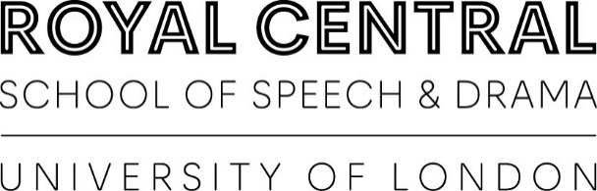

Contents

Foreword from Project Sponsor 4

Executive Summary 5

1. Introduction 7
2. Background and Context 7
   1. Context and drivers for carbon management 7
   2. Strategic themes 8
   3. Targets and objectives 8
3. Carbon Emissions Baseline and Projections 9
   1. Scope 9
   2. Baseline 9
4. Carbon Management Progress Review 10
5. Planned and New Projects 10
   1. Energy reduction and efficiency 11
   2. Other emission sources 13
   3. Behaviour change 14
6. Projected Emissions and Targets 15
   1. Projections – business as usual 15
   2. Targets 15
7. CMP Governance, Reporting and Review 16
   1. Governance for Implementation 16
   2. Implementation Plan 16

# Foreword from Project Sponsor

The Royal Central School of Speech and Drama (Central) is committed to environmental sustainability. Placing students at the centre of its work, Central develops practitioners and researchers who shape the future of theatre and performance across the UK and beyond. Central’s alumni have a notable impact on the world of British and sometimes international drama. It therefore follows that we have a responsibility to develop ‘sustainable practitioners’ to ensure that the theatre and performance are at the forefront of excellent environmental practice.

Central makes commitments in its Environmental Policy which runs alongside an Environmental and Sustainability Action Plan. This Action Plan is monitored and reviewed by a Sustainability Working Group. Commitments include:

* Establishing carbon neutral operations through improved energy efficiency and purchase of renewable energy supply.
* Minimising resource consumption and purchasing goods which have the least environmental impact throughout their lifecycle.
* Reducing waste at source wherever practicable, and re-use and recycle remainingwaste
* Assessing and making purchasing decisions on the basis of product and supplier environmental performance.
* Continuing and further developing our commitment to best practice, to awareness of current developments and to technical excellence to ensure our advice has maximum positiveimpact.
* Increasing awareness of environmental responsibilities amongst staff and students
* Involving employees and students in our environmental programme and providing necessary training to enable them to discharge their responsibilities.

Developing the Carbon Management Plan has enabled Central to access expert advice in the identification of and implementation of projects to reduce our carbon emissions to net zero by August 2050. Governors, Executive Leadership team, managers, staff and students all have an important role to play and can make a positive difference. The Central community has contributed ideas that will reduce our carbon footprint and we encourage members of the community to bring to management’s attention any further opportunities for improvement.

### Director of Operations, Vinita Suryanarayanan

# Executive Summary

This Carbon Management Plan (CMP) is available after 24 months of work completed by The Royal Central of Speech and Drama (Central) in collaboration with the Camden Climate Change Alliance (CCCA). It has received input from various technical studies from Elementa Environmental Consulting and Power Up North London. This plan is fully supported by Central’s Board of Governors and the Executive Management Team and demonstrates a firm commitment to achieving an absolute reduction in carbon emissions.

By implementing this CMP, Central will aim to reduce the carbon emissions from its buildings to net zero institution by 2030 from a 2018/19 baseline.

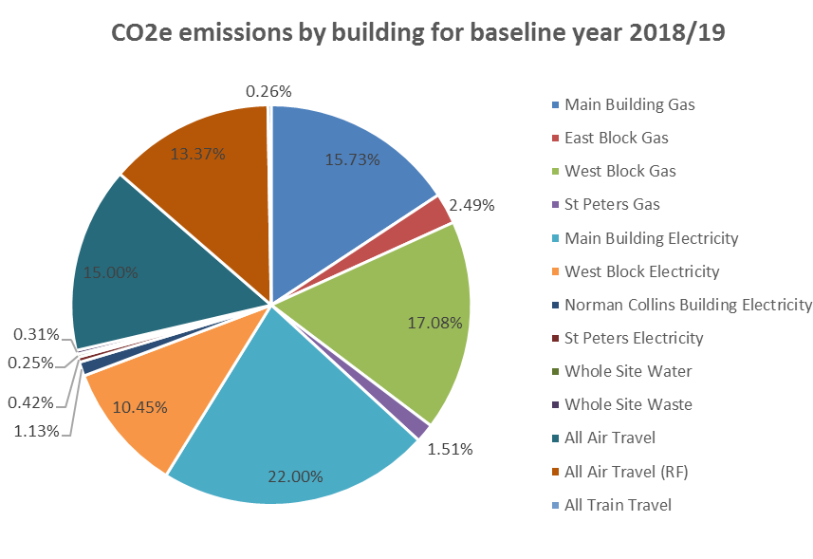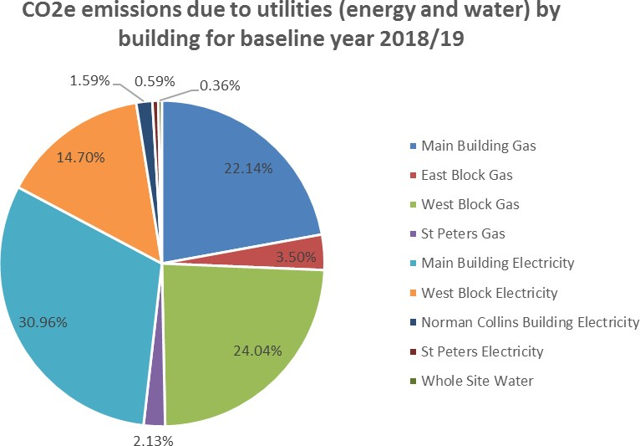

### Objectives of the Plan

* To raise awareness to staff and students about carbon emissions at Central and embed responsibility in everyone’s activities. This includes embedding sustainable practices into our curriculum and preparing and ensuring our students enter their professions and careers to lead the way in sustainable practices.
* To provide the information and implement the projects to achieve long term savings from managing carbon emissions.
* To communicate externally the commitment Central have to reducing carbon emissions.

### Ownership

This plan has been produced through the work of the Estates team following conversations and consultation with students and staff and signed off by the Governors and Finance & Estates Committee with delegating the responsibility to everyone at Central in implementing and taking the plan further.

# Introduction

This report is available after 24 months of work completed by The Royal Central School of Speech and Drama (Central) in collaboration with the Camden Climate Change Alliance (CCCA) and provides a plan for implementing carbon management at Central. The proposals outlined in this report provide details of the carbon reduction opportunities. This is the first time that wider aspects of carbon and sustainability have been included.

This implementation plan proposes the following carbon emission target:

* Scope 1 and Scope 2 aim of net zero operational carbon by 2030
* To be a net-zero carbon institution by 2050

Central will focus firstly on scope 1 & 2 emissions through reducing demand, purchasing renewable electricity and gas, and further decarbonising heating across the campus.

Tackling scope 3 emissions will require Central to reduce organisation related travel, commuting and reduce waste to reduce the overall carbon impact.

The baseline year for assessing progress towards the target is the 2018-19 academic year, for which a good level of data is available for scope 1, 2 & 3 emissions.

# Background and Context

## Context and drivers for carbon management

In 2019 the national Government passed legislation to require the UK to bring all greenhouse gas emissions to net zero in 2050 compared with the previous target of 80% reduction from 1990 levels.

The [UK Clean Growth Strategy](https://www.gov.uk/government/publications/clean-growth-strategy) set out the Government plan for meeting the UK’s fourth and fifth carbon budgets to 2032. It is noted that the public and higher education sectors are in an ideal position to show leadership in reducing energy.

The [Camden Climate Action Plan](https://www.camden.gov.uk/how-are-we-tackling-the-climate-crisis-in-camden-) developed by Camden Council for the borough also provides a net zero carbon ambition by 2030. It recognises that emissions from buildings alone in the borough contribute to 65% of direct emissions.

The Office for Students published a report in 2020 [‘Reducing Higher Education Carbon Emissions’](https://www.officeforstudents.org.uk/media/7199663b-5f6c-49f7-b231-ec5cab2adb81/bd-2020-january-71-reducing-higher-education-carbon-emissions.pdf). In it the Climate Commission for UK and Further Education is referred to which provided a public statement recommending that at a minimum for further and higher educational institutions:

* + - Scope 1 and Scope 2 aim of net zero by 2030
    - Scope 3 GHG emission net zero by 2050

This reflects the recommendations by the Intergovernmental Panel on Climate Change. The Climate Commission for UK University and College Students & Leaders also advocates the Carbon Management Hierarchy of avoid, reduce, replace, and offset. 1

Net zero carbon emissions in an operational building is defined by the UK Green building Council as:

1 <https://www.eauc.org.uk/climate_commission> [March 2020]

“*When the amount of carbon emissions associated with the building’s operational energy on an annual basis is zero or negative. A net zero carbon building is highly energy efficient and powered from on-site and/or off-site renewable energy sources, with any remaining carbon balance offset.”**2*

In 2021 Central worked with Camden Council and was provided support from Elementa Environmental Consulting and Power Up North London to devise and present an interim decarbonisation strategy. This strategy looked at the existing buildings and energy usage and identified measures both in the fabric of the building and the mechanical and engineering of the facilities that could be changed to reduce both annual energy spend and the carbon footprint, helping Central on its ambitious plan to become net zero.

## Strategic themes

The achievement of carbon emissions savings will be a responsibility for all at Central. The key first step is to raise awareness of Central’s current carbon status and in changing behaviours of those within the community. By improving housekeeping by all in all areas at Central a significant step to achieving the reduction targets can be made.

There is a requirement to improve the education and knowledge of Central’s current practices and equipment to ensure our utility plant on site is optimised to become as efficient as possible.

Central has an aspiration through its Estates capital works plan of creating sustainable and efficient buildings that are fit for our specialist purpose. Any future developments will have the further aspiration to be carbon neutral projects.

## Targets and objectives

### The Royal Central of Speech and Drama will be a net zero carbon institution by 2050.

Central have set an intermediate milestone to reduce emissions by 54% by 2025 from the 2018/19 baseline for scope 1 and 2 emissions. Scope 1 and scope 2 emissions will be net zero operational carbon by 2030 from the 2018/19 baseline. The net zero carbon by 2050 target includes scope 1,2 and 3 emissions.

2 Net Zero Carbon Buildings: A Framework Definition, April 2019 [https://www.ukgbc.org/ukgbc-work/net-](https://www.ukgbc.org/ukgbc-work/net-zero-carbon-buildings-a-framework-definition/) [zero-carbon-buildings-a-framework-definition/](https://www.ukgbc.org/ukgbc-work/net-zero-carbon-buildings-a-framework-definition/)

# Carbon Emissions Baseline and Projections

## Scope

An organisation’s emissions can be split into three different scope categories defined under the [Greenhouse Gas (GHG) Protocol Standard.](https://ghgprotocol.org/)

These are:

* + - Scope 1 – emissions produced from the use of fuels (e.g. natural gas)
    - Scope 2 – emissions produced from electricity consumption
    - Scope 3 – emissions produced from other aspects such as water, travel, waste and the supply chain

This Carbon Management Plan has considered the emissions produced through the use of utilities as well as other elements where data is available:

*Table 1: Sources of emissions covered in this CMP*

|  |  |
| --- | --- |
| **Scope** | **Source** |
| 1 | Gas |
| 2 | Electricity |
| 3 | Business Travel (Rail) |
| 3 | Business Travel (Air) |
| 3 | Business Travel (Air - Radiative forcing) |
| 3 | Commuting |
| 3 | Waste and Recycling |
| 3 | Electricity (Transmission & Distribution) |
| 3 | Gas (Well to Tank) |
| 3 | Water Supply and Treatment |

Central does not have a vehicle fleet therefore this has not been included. Data for van hire, taxis, car travel and procurement is being collated, and these aspects will be considered when the CMP Is reviewed.

## Baseline

In order to monitor the success of the project a review of the previous CMP was undertaken and a new baseline covering the additional elements established.

The baseline year for this plan is Central’s financial year 2018/2019 (August 1st 2018 – 31st July 2019) with a **total of 943 tCO2e**.

*Table 2: Baseline 2018/19 emissions by source for this CMP*

|  |  |  |
| --- | --- | --- |
| **CSSD Greenhouse Gas Emissions** | | **2018/19** |
| **Scope** | **Source** | **Tonnes of CO2e** |
| 1 | Gas | 224.86 |
| 2 | Electricity | 239.62 |
| **Scope 1 and 2 Emissions** | | **464.48** |
| 3 | Business Travel (Rail) | 1.82 |
| 3 | Business Travel (Air) | 103.55 |
| 3 | Business Travel (Air - Radiative forcing) | 92.32 |
| 3 | Commuting - staff | 90.30 |
| 3 | Commuting - students | 133.97 |
| 3 | Waste and Recycling | 2.09 |
| 3 | Electricity Scope 3 | 20.43 |
| 3 | Gas Scope 3 | 29.24 |
| 3 | Water Supply and Treatment | 5.37 |
| **Scope 3 Emissions** | | **479.09** |
| **Total Annual Emissions** | | **943.58** |

# Carbon Management Progress Review

5. Planned and New

Projects

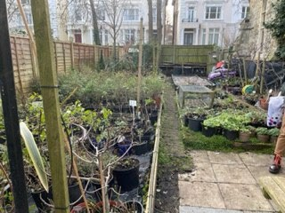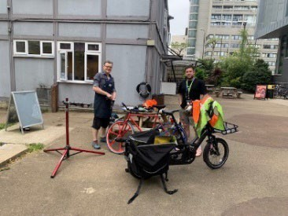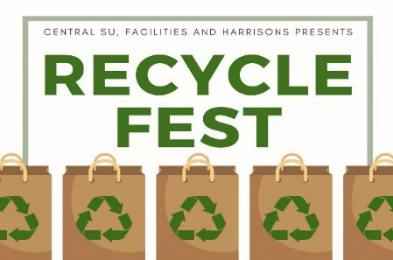

A

range

of carbon

reduction projects

are A

10

**Carbon and Sustainability Awareness**

Central have undertaken awareness and behaviour change campaigns for staff and students covering a range of areas. Some examples include:

Sustainable travel - Cycle to Work scheme, Dr Bike visits Waste and recycling – ‘Recycle Fest’

Biodiversity – St Peters Gardening, ‘Green Roadshow’, ‘May Day Gardening Party’

A number of carbon reduction projects have already been implemented as part of the previous Carbon Management Plan (2009/10 – 2019/20), including energy supply projects and energy demand reduction projects. Whilst not covered in the previous Carbon Management Plan a number of wider sustainability initiatives have also taken place. We have also undertaken a decarbonisation study and are in the process of implementing air source heat pumps.

### Solar Photovoltaic (PV) Installation

Solar photovoltaics were installed on the Old Building in 2019.

### Energy and Utility Efficiency Projects

The facilities management team has implemented an extensive programme of small-medium electricity, gas and water efficiency projects relating to lighting, small appliance use, building management system (BMS) controls and local boiler efficiency. The projects focussed on short- medium payback projects across the sites. These included the replacement of lighting with LED retrofit.

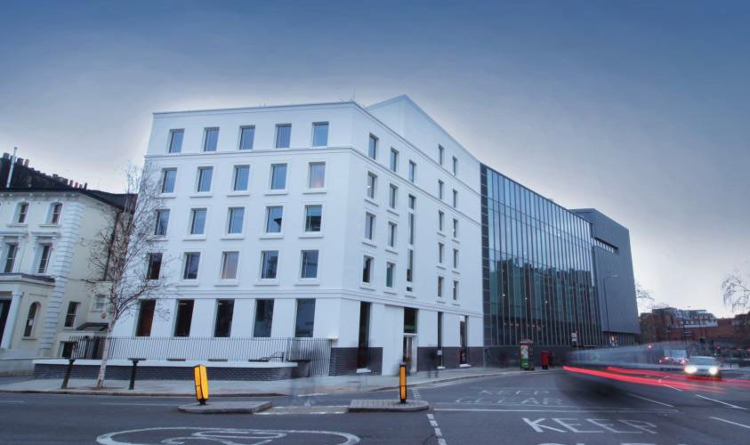

**BREEAM Excellent new build of North Block** The new North Block building to [BREEAM](https://www.breeam.com/) Excellent standard was opened in 2019. The block offers a studio, 5 high ceiling rehearsal spaces and a new public theatre utilising sustainable, LED lighting and professional audio equipment.

A range of carbon reduction projects are planned/have been identified covering energy demand reduction as well as waste and more sustainable travel. Costs are considered separately as part of the investment plan. Refer to the appendix for more project details.

## Energy reduction and efficiency

Projects considered by building in terms of fabric, heating system, ventilation, and other energy efficiency measures.

|  |  |  |  |
| --- | --- | --- | --- |
| East Block |  |  | Time |
| Fabric |  |  |  |
| Ref 1.1 | Roof | Additional insulation to be added to roof to reduce  heat losses | By 2030 |
| Ref 1.2 | Wall | Additional insulation to be added to walls to reduce heat losses. Viability of external wall insulation (EWI),  cavity wall insulation, or internal wall insulation (IWI) to be explored | By 2030 |
| Ref 1.3 | Glazing | Replace existing poor double glazing with new triple  glazing to reduce heat losses | By 2030 |
| Ref 1.4 | Rooflights | Replace existing poor double glazing with new triple  glazing to reduce heat losses | By 2030 |
| Ref 1.5 | Doors | Replace existing glazed doors with new to reduce  heat losses | By 2030 |
| Heating  System |  |  |  |
| Ref 1.6 | Heating  system | Replacement of old gas boilers to heat pump to  significantly reduce energy use for heating demand. | End 2022 |
| Ventilation Heat  Recovery |  |  |  |
| Ref 1.7 | Ventilation system | AHU serving student bar is old and should be replaced with new, with lower specific fan power and  heat recovery as detailed below | By 2030 |
| Ref 1.8 | Heat  recovery | If a new AHU was installed it could use plate heat  exchangers or a thermal wheel for heat recovery | By 2030 |
| Ref 1.9 | Domestic Hot Water  system | New point of use water heaters could provide some energy savings but not recommend till existing ones  come to their end-of-life | Ongoing |

|  |  |  |  |
| --- | --- | --- | --- |
| Main building, embassy theatre & embassy extension | | | Time |
| Fabric |  |  |  |
| Ref 1.10 | Roof | Additional insulation to be added to roof to reduce heat losses | By 2030 |
| Ref 1.11 | Wall | Additional insulation to be added to walls to reduce heat losses. Viability of external wall insulation (EWI), cavity wall insulation, or internal wall insulation (IWI)  to be explored | BY 2030 |
| Ref 1.12 | Glazing | Replace existing single glazing in main building with  sympathetic double glazing and double glazing in | By 2030 |

|  |  |  |  |
| --- | --- | --- | --- |
|  |  | embassy extension with triple glazing to reduce heat losses |  |
| Ref 1.13 | Rooflights | Replace existing poor double glazing with new triple glazing to reduce heat losses. Rooflights only occur in  embassy extension. | By 2030 |
| Ref 1.14 | Doors | Replace existing glazed doors with new to reduce  heat losses | By 2030 |
| Heating  System |  |  |  |
| Ref 1.15 | Heating  system | Replacement of old gas boilers to heat pump to  significantly reduce energy use for heating demand. | End 2022 |
| Ventilation heat  recovery |  |  |  |
| Ref 1.16 | Ventilation system | AHUs serving the various space could be replaced with new, with lower specific fan power, but only recommended when existing AHU come to their end-  of-life. | By 2025 |
| Ref 1.17 | Heat  recovery | If a new AHU was installed it could use plate heat  exchangers or a thermal wheel for heat recovery | By 2030 |
| Ref 1.18 | Domestic Hot Water  system | New point of use water heaters could provide some energy savings but not recommend till existing ones  come to their end-of-life | By 2030 |
| Other |  |  |  |
| Ref 1.19 | Flow  restrictors | Estimated that flow restrictors on these fittings could  reduce hot water consumption by 40% | By 2025 |
| Ref 1.20 | Lighting | Estimated that 40% of all lighting has already been  switched to LED, proposed to replace the remaining | Ongoing |

|  |  |  |  |
| --- | --- | --- | --- |
| West Block & North Block | |  | Time |
| Heating  System |  |  |  |
| Ref 1.21 | Heating  system | Replacement of old gas boilers to heat pump to  significantly reduce energy use for heating demand. | End 2022 |
| Ventilation heat  recovery |  |  |  |
| Ref 1.22 | Heat  recovery | If a new AHU was installed it could use plate heat  exchangers or a thermal wheel for heat recovery | By 2030 |
| Ref 1.23 | Domestic Hot Water system | Switch gas boilers to heat pump as per the heating system but retain the existing point of use. A heat pump will significantly reduce energy use for meeting the water heating demand. New point of use water heaters could provide some energy savings but not recommend till existing ones come to their end-of-  life. | By 2030 |
| Other |  |  |  |
| Ref 1.24 | Flow  restrictors | Upgrade all taps in west block with flow restrictors. | By 2025 |

|  |  |  |  |
| --- | --- | --- | --- |
| Ref 1.25 | Waste Water Heat  Recovery | Upgrade west block showers. | By 2025 |

|  |  |  |  |
| --- | --- | --- | --- |
| Site-wide |  |  | Time |
| Ref 1.26 | PV | Additional PV panels to increase the amount of  onsite renewable energy generation. | By 2030 |
| Ref 1.27 | Sub meters | Installation of sub meters to monitor buildings | Aug 2022 |
| Ref 1.28 | Renewable  electricity | Aim to purchase 100% REGO backed renewable  electricity | Aug 2025 |
| Ref 1.29 | Lighting Sensors Installatio  n | Lighting passive infrared sensors installed (PIRs) | By 2025 |
| Ref 1.30 | IT Switch Off | An automated shut down would ensure they are not left on utilising energy and generating heat which would result in the excessive operation of the cooling plant. | By 2025 |

## Other emission sources

|  |  |  |  |
| --- | --- | --- | --- |
| Site-wide |  |  | Time |
| Ref 2.1 | Waste and  Recycling | Continue with zero waste to landfill | Ongoing |
| Ref 2.2 | Waste and  Recycling | Plastic free/ban single use plastics. Switching to  reusables and compostables | By 2024 |
| Ref 2.3 | Water Supply and  Treatment | Toilet upgrade - Main building toilet replacement and refurbishments. | By 2025 |
| Ref 2.4 | Business Travel | A large proportion of scope 3 emissions is business travel emissions. There is a current policy in place. Admissions are currently looking at the requirements for in-person for auditions. Attendance at conferences is also being rotated. | Ongoing, policy reviewed annually |
| Ref 2.5 | Commuting | Central undertake annual travel surveys to understand staff and student's current travel habits and inform future actions | August 2022  thereafter  annually |
| Ref 2.6 | Commuting | Central run events and provide information to increase the uptake of public and active transport  among staff and students. | Ongoing |
| Ref 2.7 | Commuting | Update travel plan | 2022/23 |
| Ref 2.8 | Commuting | Flexible home working policy to be considered | 2022/23 |

## Behaviour change

|  |  |  |  |
| --- | --- | --- | --- |
| Site-wide |  |  | Time |
| Ref 3.1 | Environment Awareness and Behaviour Change Campaign | An annual programme to be run including:   * Screenings of Climate Change movies for staff and students (joint events) * Series of environmental awareness events covering multiple sustainability areas – link to initiatives such as apps (e.g. Olio) and external organisations that can help * Student and staff environmental champions and committee to drive forward the engagement programme. * Ongoing communications internally including website updates and emails. | Autumn 2022 and ongoing annually |
| Ref 3.2 | Sustainable Student Materials and  Curriculum |  | 2023/24 |

# Projected Emissions and Targets

## Projections – business as usual

The Business as Usual projected carbon emissions (BAU) is based on the 2018/19 energy consumption (scope 1 and 2) and if no projects were implemented.

The BAU model assumes that the level of staff and students remains static and there will be no major Estate development over this period. There have been major works in the last two years with the introduction of the new block, however there are no other major works in the pipeline that will create an increase in demand.

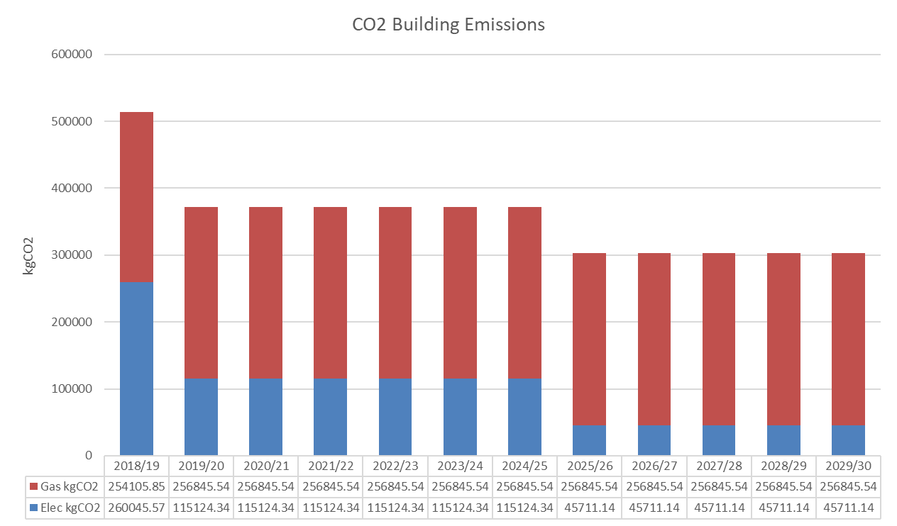

## Targets

Targets for energy consumption (scope 1 and 2) are based on a net zero ambition by 2029/30. This sees a required 54.54% reduction in scope 1 and 2 by 2024/25.

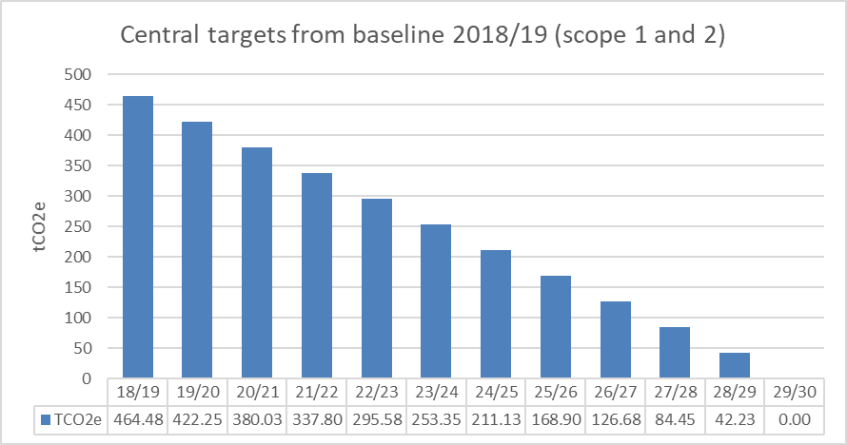

Following reduction and efficiency measures carbon offsetting will be used as final option to achieve net zero.

# CMP Governance, Reporting and Review

## Governance for Implementation

Central are committed to embedding good practice and considering carbon emissions at an individual level throughout the organisation. The establishment of the Sustainability Working Group with representatives from staff and students enabling monitoring and new ideas assists in embedding sustainability and continual improvement.

The tools used to drive good practice and awareness in carbon reduction will be through regular communications via email, publications on Central’s website as well as reporting on the progress of the CMP annually in respect of performance against carbon emission targets and project implementation.

Central are committed to embedding carbon management and best practice sustainability across the organisation by both staff and students. The risks and mitigating factors of the implementation of the Carbon Management Plan is also described in our Departmental and Operational Risk Register. Potential blocks such as costs, affordability and slow change management procedures will all be considered in the action plan. The governance structure whereby Central will work towards achieving the targets of this place is set out in the chart below:

**Finance & Estates Committee**

*for approval of budget and review progress against plan*

**Executive Management Team**

*Senior representatives from across teams, for review, execution and recommendation for approval. Meets twice a term.*

**Sustainability Working Group**

*representatives of staff and students, for ideas and taking action as necessary. Task and finish group.*

## Implementation Plan

The implementation of this CMP has already begun. Projects have been identified and some have already been completed. Achieving carbon savings through refurbishment works, optimising current equipment and rationalising current processes is now at the fore of the Central’s activities. There are further projects to be identified and assigned to the correct departments. There is then a process of tendering for and executing of projects. These will then be monitored and reviewed closely through the working mechanisms of Central.

The Director of Operations will have overall responsibility for the leadership and delivery of the plan and act as the Advisory support and will provide updates and reports annually to the Executive Management Team which will remain in place to act as the driver for all works. The progress of carbon reduction and future targets will be at the fore of the Strategic Plan each year and will be presented to the Board as an audit of current status and progress towards targets.

Appendix: Further detail of key projects

|  |  |
| --- | --- |
| **Energy** |  |
| Project | Fabric |
| Reference | 1.1 - 1.5, 1.10 - 1.14 |
| Owner | Estates Manager |
| Department | Facilities and Estates |
| Description | East Block  Roof - Additional insulation to be added to roof to reduce heat losses  Wall - Additional insulation to be added to walls to reduce heat losses. Viability of external wall insulation (EWI), cavity wall insulation, or internal wall insulation (IWI) to be explored  Glazing - Replace existing poor double glazing with new triple glazing to reduce heat losses  Rooflights - Replace existing poor double glazing with new triple glazing to reduce heat losses  Doors - Replace existing glazed doors with new to reduce heat losses |
| Benefits | 14% reduction in carbon emissions3 |
| Funding | Investment plan budget |
| Timing | August 2022 |

|  |  |
| --- | --- |
| **Energy** |  |
| Project | Heating system |
| Reference | 1.6, 1.15, 1.21 |
| Owner | Estates Manager |
| Department | Facilities and Estates |
| Description | Replacement of old gas boilers to heat pump to significantly reduce energy use for  heating demand. |
| Benefits | 32% reduction in carbon emissions4 |
| Funding | Investment plan budget and Public Sector Decarbonisation Scheme (PSDS) |
| Timing | August 2022 |

|  |  |
| --- | --- |
| **Energy** |  |
| Project | Ventilation and Heat Recovery |
| Reference | 1.16-1.18, 1.22,1.23 |
| Owner | Estates Manager |
| Department | Facilities and Estates |
| Description | East, Main building, embassy theatre & embassy extension, West Block & North  Block. Replacement of AHU and point of water heaters |
| Benefits | 3% reduction in carbon emissions5 |
| Funding | Investment plan budget |
| Timing | By 2030 |

3 Decarbonisation Feasibility Study Table 9.3

4 Decarbonisation Feasibility Study Table 9.3

|  |  |
| --- | --- |
| **Energy** |  |
| Project | Solar PV (additional and existing) |
| Reference | 1.26 |
| Owner | Estates Manager |
| Department | Facilities and Estates |
| Description | Currently 83 panels generating approximately 11,000kWh annually with 50% used on-site. Additional 72 panels recommended providing an additional 21,900kWh annually. Proposed to use all PV generated electricity on-site as Feed in Tariff no  longer available. |
| Benefits | Energy savings: 27,400kWh annually (including 50% of current) 6 |
| Funding | Through investment plan budget |
| Timing | By 2030 |