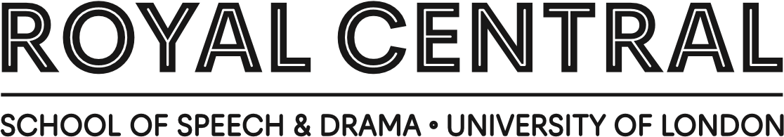

Donation Form
Thank you for considering a donation to support The Royal Central School of Speech and Drama.
Full name(s):

Home address:

Postcode:

Country: Telephone:

Email:

How we manage your data
I would like to receive news from Central, as well as information about Central events, activities, services, benefits, products, opportunities to support, volunteering and courses or other initiatives that may be of interest to me. By ticking this box I confirm that I give consent to be sent these communications by email. Please note that if you do not opt-in to email communications we may still send you relevant information via post.
I understand that the School collects, holds and uses the contact data I have supplied under the terms of the current General Data Protection Regulations. I am aware that I can find further information about how my data is used in the School’s Data Protection and Records Retention Policy, or I can contact the fundraising team and ask them to post me a copy.

Gift Aid: boost your donation by 25p for every £1 you donate
By ticking this box I confirm that I am a UK tax payer and would like all my donations, past, present and future, to The Royal Central School of Speech and Drama to be treated as Gift Aid donations.
I confirm that I have or will have paid sufficient tax (income or capital gains) in the current tax year to cover all the tax that will be reclaimed by all the charities or CASC to which I have made Gift Aid donations. I understand that other taxes, such as council tax and VAT do not qualify. I understand that if I pay less Income Tax and/or Capital Gains Tax than the amount of Gift Aid claimed on all my donations in that tax year it is my responsibility to pay any difference.
Please notify The Royal Central School of Speech and Drama if you:
- want to cancel this declaration
- change your name or home address
- no longer pay sufficient tax on your income and/or capital gains.
I would like someone to contact me about leaving a legacy to Central

How to make a monthly or yearly gift
Please complete this page if you wish to make a monthly or yearly gift to Central.
I wish to give £ ............................. by Direct Debit monthly/annually (delete as appropriate) until I give further notice, starting on the 1st of ................................................... (month) ...................... (year).
I wish my gift to go towards Pivot Club membership
I wish to give to bursaries at Central
Instruction to your bank or building society
Please pay Central School of Speech and Drama direct debits from the account detailed in this Instruction subject to the safeguards assured by the Direct Debit Guarantee. I understand that this instruction may remain with Central School of Speech and Drama and, if so, details will be passed electronically to my bank/ building society
Signature:

Date:

Banks and building societies may not accept Direct Debit Instructions for some types of account
Instruction to your bank or building

society to pay by Direct Debit
Instruction to your bank or building society to pay
by Direct Debit
Name(s) of account holder(s):
Bank/building society account number:
Branch sort code:
Name and full postal address of your bank or

building society:
To: The Manager, Bank/Building Society:
Address:
Postcode:
FOR THE ROYAL CENTRAL SCHOOL OF SPEECH AND
DRAMA OFFICIAL USE ONLY
This is not part of the instruction to your bank or
building society.
I wish to make my donation to The Royal Central School
of Speech and Drama on an (please select an option
below):

Annual basis starting on the first of:
)
write month here
(

Monthly basis starting on the first of:
)
write month here
(
Reference (to be completed by The Royal Central School of Speech and Drama):
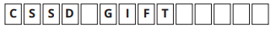

Service User number:
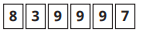

The Direct Debit Guarantee
This Guarantee is offered by all banks and building societies that accept instructions to pay Direct Debits If there are any changes to the amount, date or frequency of your direct debit, Central School of Speech & Drama will notify you 10 working days in advance of your account being debited or as otherwise agreed. If you request Central School of Speech & Drama to collect a payment, confirmation of the amount and date will be given to you at the time of the request.
If an error is made in the payment of your Direct Debit, by Central School of Speech & Drama or your bank or building society you are entitled to a full and immediate refund of the amount paid from your bank or building society. If you receive a refund you are not entitled to, you must pay it back when Central School of Speech & Drama asks you to. You can cancel a Direct Debit at any time by simply contacting your bank or building society. Written confirmation may be required. Please also notify us.

How to make a single gift
Please complete this page if you wish to make a single gift to Central.
I wish to give to support Central
I wish to give to bursaries at Central (helping students with study and living costs)
I wish to give a project already agreed with Central
I wish to make a single gift of:
£30 £50 £100 £250 £500 £1000
Other £ ………………............…..........
Please attach your cheque or charity voucher made payable to the ‘Royal Central School of Speech and Drama’ to this form. Alternatively, please phone +44 (0)20 7449 1636 during office hours to make your donation by credit / debit card.
You can also make your single gift by bank transfer and we ask that you email us to let us know if you donate by bank transfer:
Account Number: 01145981
Account Name: The Royal CSSD – Fundraising a/c
Sort Code: 30-18-43
IBAN: GB43LOYD30184301145981
Please return this form to:
Development and Alumni Engagement
The Royal Central School of Speech and Drama
Eton Ave
London
NW3 3HY UK
Thank you for your donation and for making a difference.

Contact us
Please do contact us with any queries or to learn more about any of the above at development@cssd.ac.uk or +44 (0)20 7449 1636

